Generating an ATL Execution Trace as a Traceability Weaving Model

Introduction
We use ATL to transform from a simple object model into a relational model. The ATL transformation is modified to generate traceability information.
The example is a simple transformation from Class to Relational models (Class2Relational.atl). The original transformation does not generate traceability information. However adding traceability information enables to know which input elements generated a given output element, and by which ATL rule as well.
The transformation ATL2WTracer.atl is a transformation that takes an ATL model as input and produces an ATL model that generates traceability information. The Class2Relational.atl transformation is transformed into Class2Relational-WithWTracer.atl. The transformation Class2Relational-WithWTracer.atl transforms Class to Relational models, and additionally generates a traceability model.
The traceability model conforms to an extension of the core weaving metamodel. A weaving model captures links between model elements. We extended the weaving metamodel with a traceability extension. The ATLAS Model Weaver prototype [2] is a tool to manipulate weaving models. In its actual implementation state, the tool needs exact information about the file paths. This information is not generated by the ATL transformation. We describe in this document how to load a traceability model in the AMW prototype.

The traceability metamodel extension

The traceability fragment below is an extension to the core weaving metamodel. The core weaving metamodel is available in the Atlantic Zoo (http://www.eclipse.org/gmt/am3/zoos/), mwcore.km3.

package mw_traceability {

class TraceModel extends WModel {
reference wovenModels[*] container subsets wovenModel : TraceModelRef;
}

class TraceModelRef extends WModelRef {
reference ownedElementRef[*] container : ElementRef oppositeOf modelRef;
}
-------------------------------------------------------------------
class TraceLink extends WLink{
attribute ruleName : String;
reference sourceElements[*] ordered container subsets end : WLinkEnd;
reference targetElements[*] ordered container subsets end : WLinkEnd;
}

class ElementRef extends WElementRef {
reference modelRef: TraceModelRef oppositeOf ownedElementRef;
}
class TraceLinkEnd extends WLinkEnd {
}

}

Traceability Model

The code below shows the traceability model generated by the ATL transformation in XMI. The path information should be at lines 1 and 12. They do not have information about where the traced models are. The information that relates a referred model with his path is the name plus the ref attribute (the ref attribute information is missing in the model and will the automatically generated by AMW). We produce a traceability model using IN and OUT as names, but any arbitrary name may be chosen.

1 <wovenModels xsi:type="TraceModelRef" name=”IN”>
2 <ownedElementRef ref="/1"/>
3 <ownedElementRef ref="/0"/>
4 <ownedElementRef ref="/2"/>
5 <ownedElementRef ref="/3"/>
6 <ownedElementRef ref="/1/@attr.0"/>
7 <ownedElementRef ref="/0/@attr.0"/>
8 <ownedElementRef ref="/1/@attr.2"/>
9 <ownedElementRef ref="/1/@attr.1"/>
10 <ownedElementRef ref="/0/@attr.1"/>
11 </wovenModels>
12 <wovenModels xsi:type="TraceModelRef" name=”OUT”>
13 <ownedElementRef ref="/0"/>
14 <ownedElementRef ref="/0/@col.0"/>
15 <ownedElementRef ref="/1"/>
16 <ownedElementRef ref="/1/@col.0"/>
17 <ownedElementRef ref="/2"/>
18 <ownedElementRef ref="/3"/>
19 <ownedElementRef ref="/0/@col.1"/>
20 <ownedElementRef ref="/1/@col.1"/>
21 <ownedElementRef ref="/4"/>
22 <ownedElementRef ref="/4/@col.0"/>
23 <ownedElementRef ref="/4/@col.1"/>
24 <ownedElementRef ref="/0/@col.2"/>
25 <ownedElementRef ref="/5"/>
26 <ownedElementRef ref="/5/@col.0"/>
27 <ownedElementRef ref="/5/@col.1"/>
28 </wovenModels>

Loading the traceability model in AMW

We describe step-by-step how to load the modified traceability model into AMW:

In Eclipse, choose File -> New -> Model Weaver -> Weaving Model. A wizard page will open.
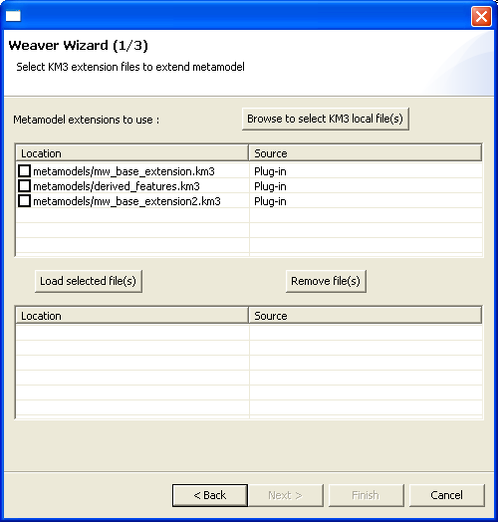

Click on Browse to select KM3 local file(s) and choose the mw_traceability.km3 file from the workspace.

Select the mw_base_extension.km3 and mw_traceability.km3 and load them.
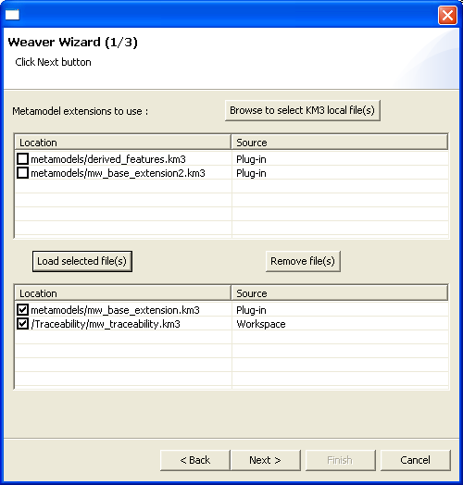

In the second page, choose Use Existing Model and select the modified traceability model. In the drop-down list with the choice of WModels, choose, TraceModel.

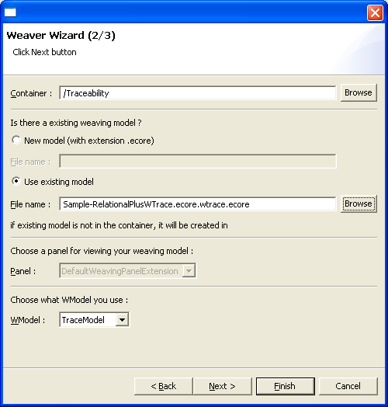

On the next screen click on Add a model. In the Name input fill with the same name specified in the traceability model. In our example we put OUT. It must be the same name as specified in the traceability model. Choose the metamodel and model (Relational.ecore and Sample-RelationalPlusWTrace.ecore Class.ecore and Sample-Class.ecore). The same must be done for the IN model (Relational.ecore and Sample-RelationalPlusWTrace.ecore).

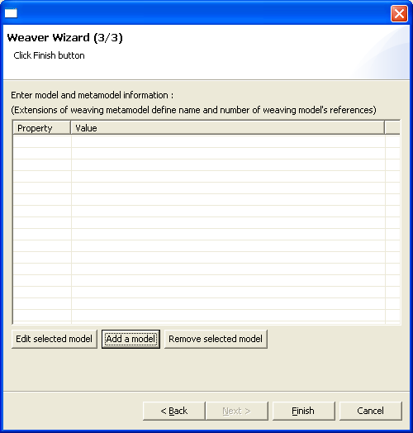
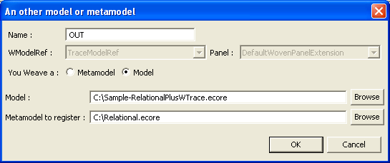

The final result (the traceability model) is shown in the AMW interface.

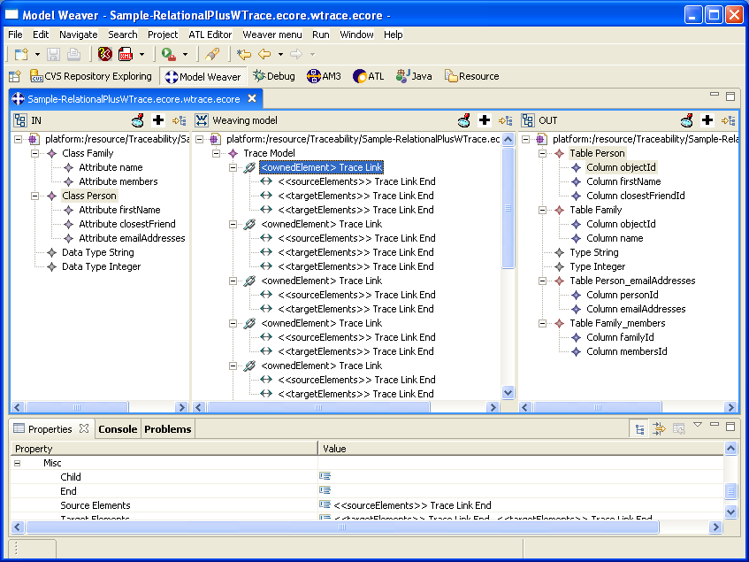

- Jouault F. Loosely Coupled Traceability for ATL. In: Proceedings of the European Conference on Model Driven Architecture (ECMDA 2005) workshop on traceability, Nuremberg, Germany
- ATLAS Model Weaver. http://www.eclipse.org/gmt/amw/

Version info
This example was developed using the following versions of AMW and ATL:
- AMW: July 26th 2006
- ATL: January 13th, 2006

